AGREEMENT
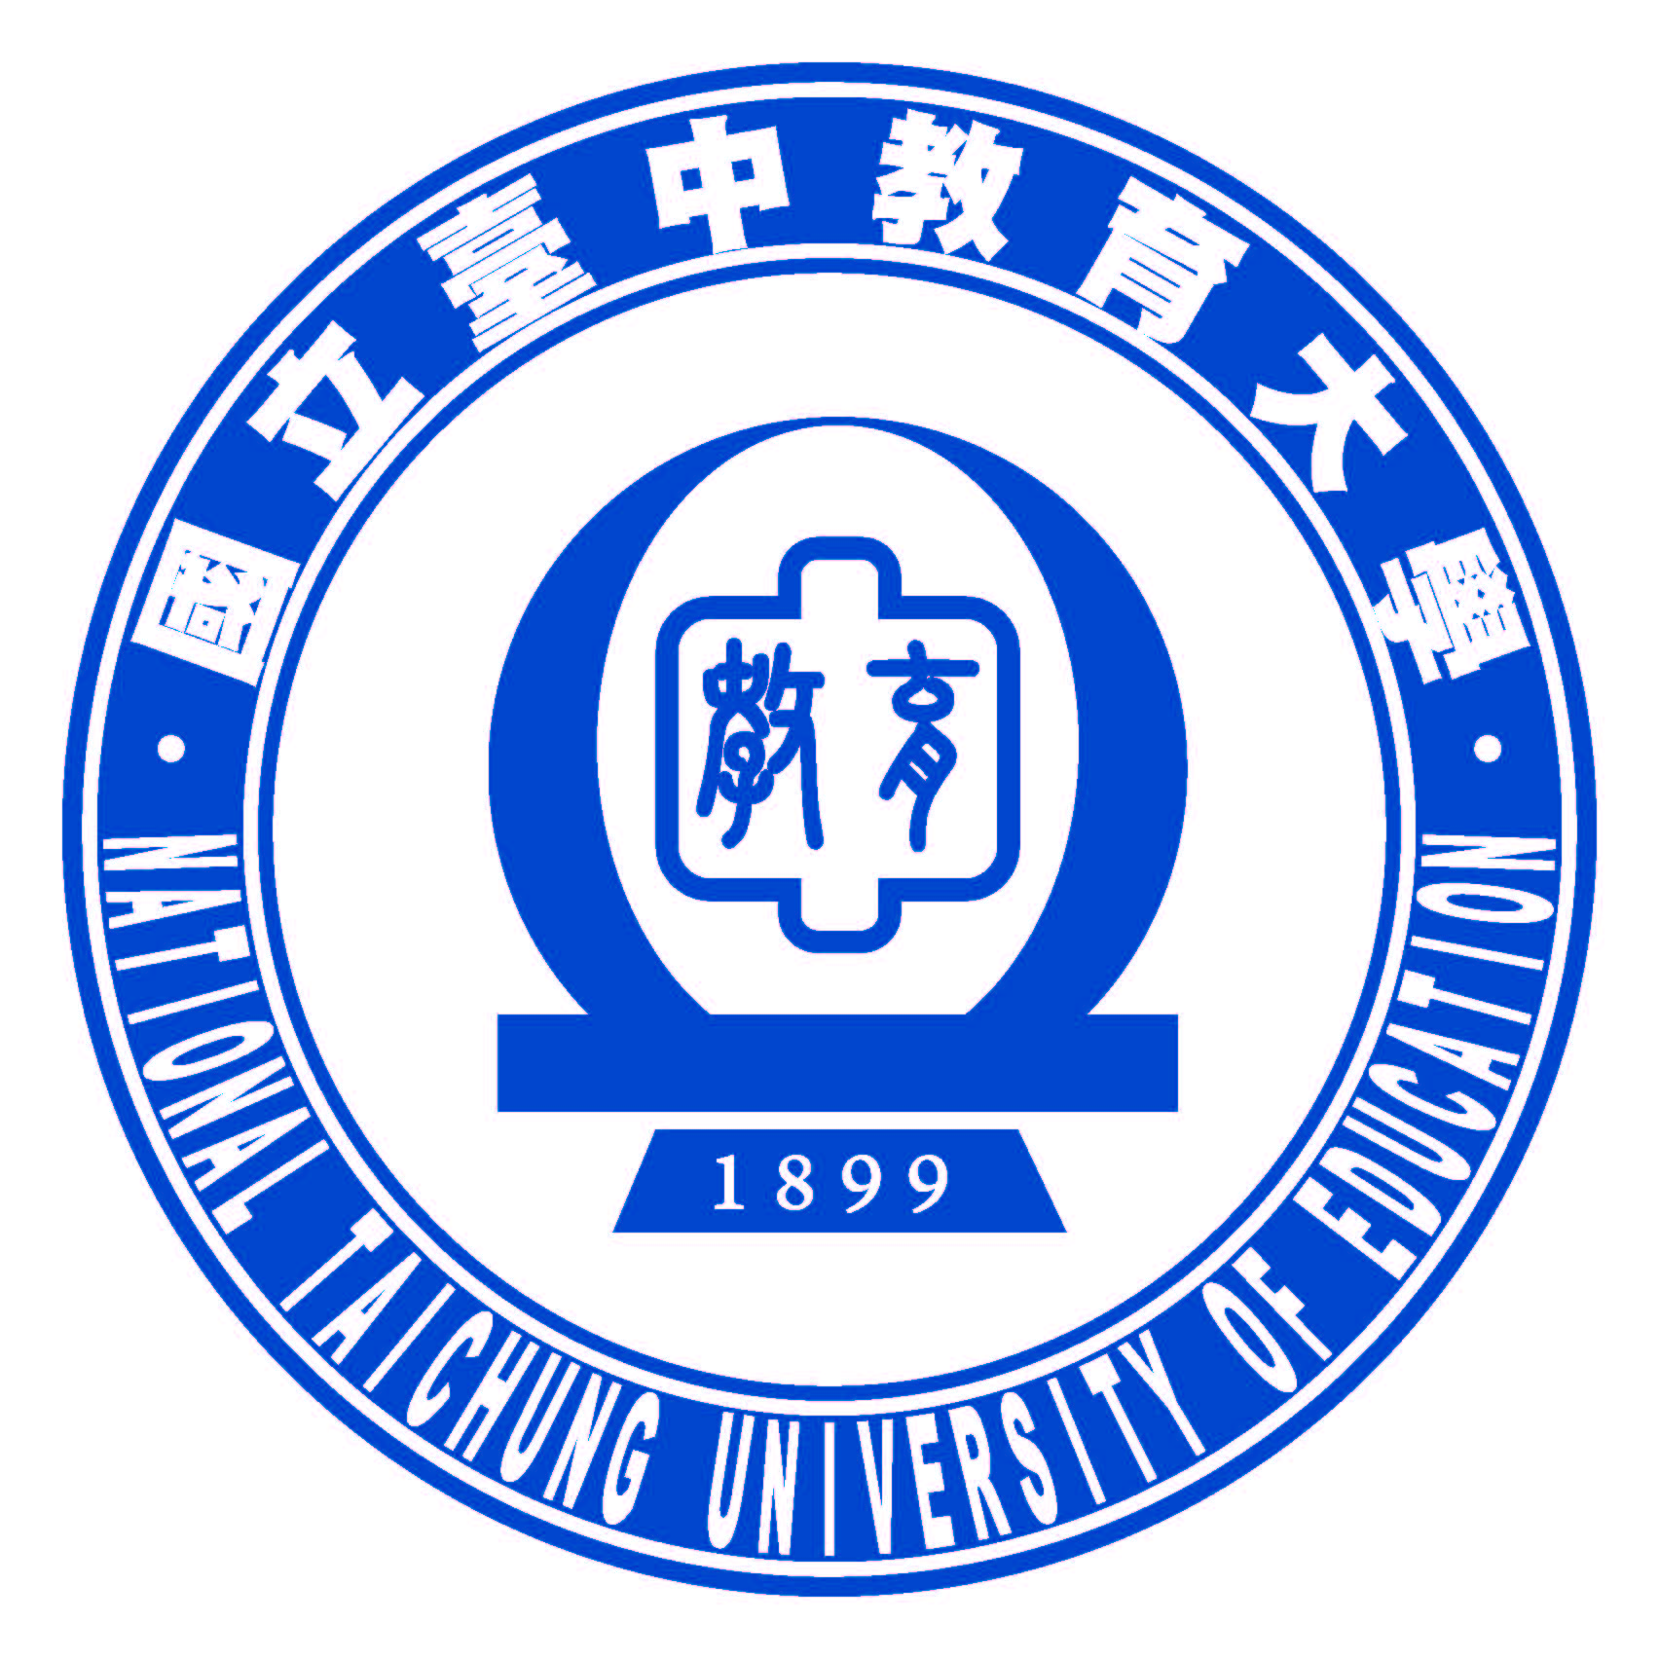
OF A STUDENT EXCHANGE PROGRAM
BETWEEN
○○ UNIVERSITY
AND
NATIONAL TAICHUNG UNIVERSITY OF EDUCATION

○○ University and National Taichung University of Education will participate in the exchange of students under the following terms. These details will serve to provide the working framework for the academic exchange program.

1. The students are to be exchanged for either one full academic year or one semester.

2. Each academic year one institution will allow no more than 2 students from the other institution to enroll as exchange students. The actual number of students to be exchanged will be determined every year by mutual consultation in advance.

3. The exchange students are required to be regular students who are registered in the bachelor, master, or doctoral program at the home institution.

4. The students who participate in the exchange program will be initially selected by the home institution, and the host institution will make the final decision of admission in each case.

5. The students will determine the detailed study plan at the host institutions in consultation with academic advisors of both home and host institutions.

6. The students must possess the level of language proficiency that is requested by the host institution in order to be accepted and complete the appropriate course of study.

7. The host institution will evaluate the academic performance of each student according to its rules and will send to the home institution the academic record/transcript of each exchange student. The home institution may give academic credits to each student according to its regulations.

8. The host institution will waive academic tuition and fees for the exchange students.

9. The students shall be responsible for their own expenses, including travel expenses, accommodation and health insurance fees.

10. This agreement will enter into and be effective as of the date of its signing by the representatives of both institutions and shall be in force for the same period as the General Academic Cooperation Agreement.

11. Variation from the above terms may be possible by mutual consent.

12. This agreement is to be executed in the English language.

SIGNED BY:

..…..……..…………………………..  ○○○  President  ○○ University  ……………………………………….  DATE |  | ..…..……..…………………………..  Dr. Bor-Chen Kuo  President  National Taichung University of Education  ……………………………………….  DATE

